GLOBAL LAYOFFS TRENDING ANALYSIS(2020 – 2025)
STAGE 4 – DOCUMENTATION, INSIGHTS & PRESENTATION
1. Introduction
Stage 4 focuses on presenting the final analysis results through a dashboard, summarizing insights, and providing business recommendations. The goal is to convert data analysis into meaningful information that supports decision-making.
2. Dashboard Overview
A dashboard was created using Microsoft Power BI to visually represent layoffs data.
The dashboard includes multiple charts such as:
- Layoffs by Industry
- Layoffs by Country
- Year-wise Layoffs Trend
- Top Companies by Layoffs
- Funding vs Layoffs (Scatter Plot)
It also includes KPI cards and filters (slicers) for better interactivity.
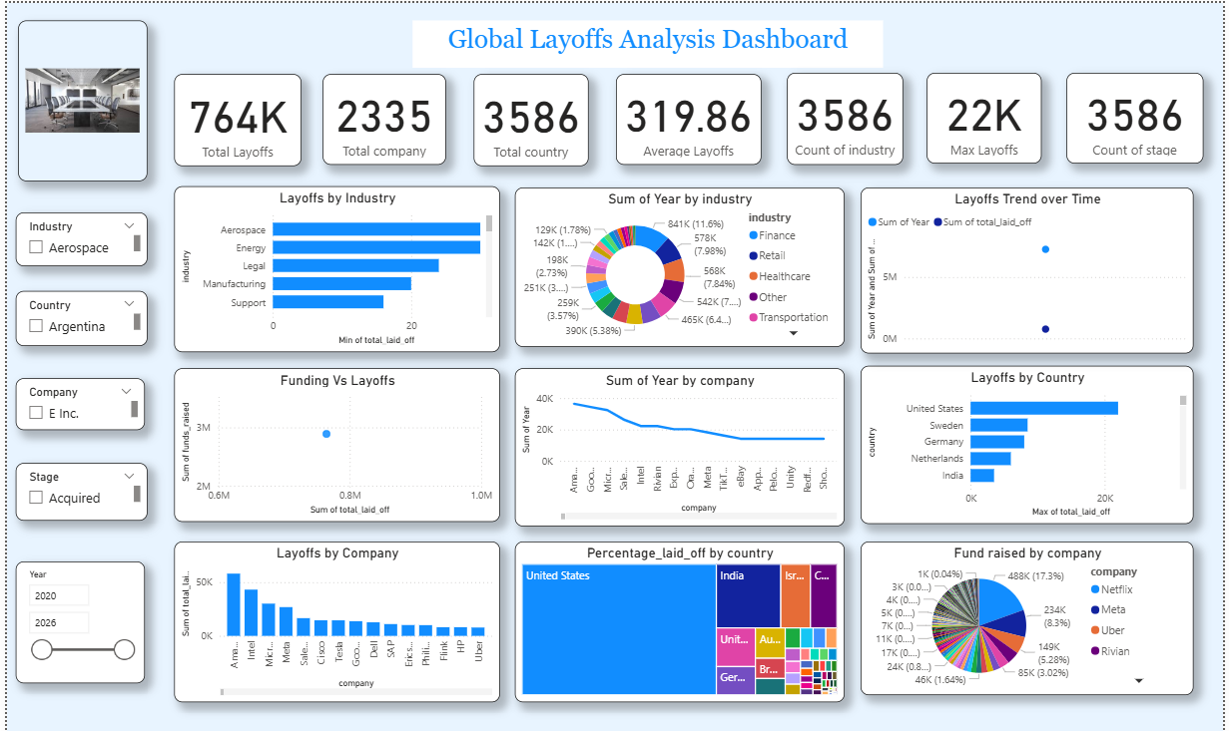
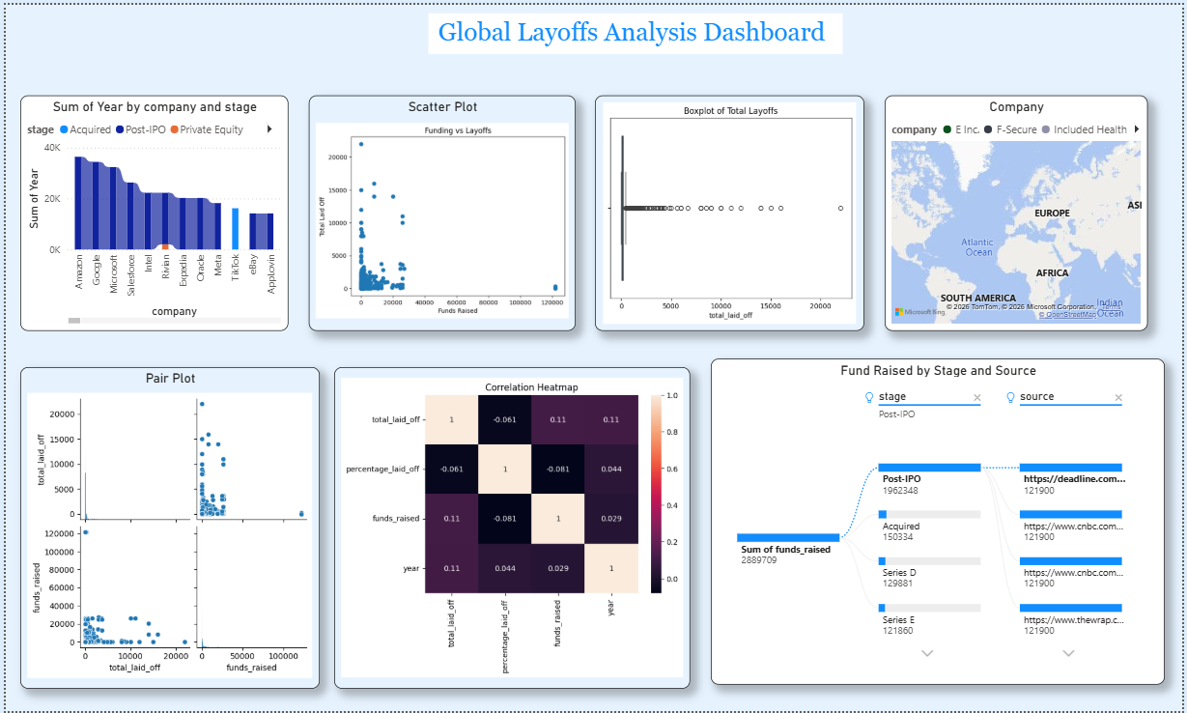

3. Summary of Findings (Plain English)
The analysis shows that layoffs are not evenly distributed across industries and countries.
The technology sector accounts for a large portion of layoffs, indicating major restructuring in that industry.
Layoffs have increased in recent years, suggesting the impact of economic conditions and business challenges.
Additionally, layoffs are concentrated in specific countries, showing regional impact.
Even companies with high funding are laying off employees, which indicates that layoffs are influenced by strategic decisions and not just financial limitations.
4. Key Insights
- The technology industry experienced the highest layoffs
- Layoffs increased significantly over time
- A small number of companies contributed to very large layoffs
- Layoffs are concentrated in a few countries
- No strong relationship between funding and layoffs
5. Business Recommendations
Based on the analysis, the following recommendations are provided:
- Companies should improve workforce planning to avoid sudden layoffs
- Organizations should invest in employee reskilling and upskilling
- Businesses should diversify their strategies to reduce risks
- Cost optimization should be considered before layoffs
- Governments can support affected industries and workers
6. Final Story with Dashboard
The dashboard provides a complete view of global layoffs trends.
The KPI section gives an overview of total layoffs and affected companies.
The industry chart highlights that the technology sector has the highest layoffs.
The country chart shows that layoffs are concentrated in specific regions.
The trend chart indicates that layoffs have increased in recent years.
The scatter plot shows that there is no strong relationship between funding and layoffs.
Overall, the dashboard demonstrates that layoffs are influenced by multiple factors such as industry trends, economic conditions, and company strategies.
7. Conclusion
In conclusion, this stage presents the final outcomes of the project through a dashboard and insights.
The analysis helps in understanding workforce reduction patterns and provides valuable information for business decision-making.
The dashboard makes it easier to interpret data and supports organizations in planning better strategies for the future.

